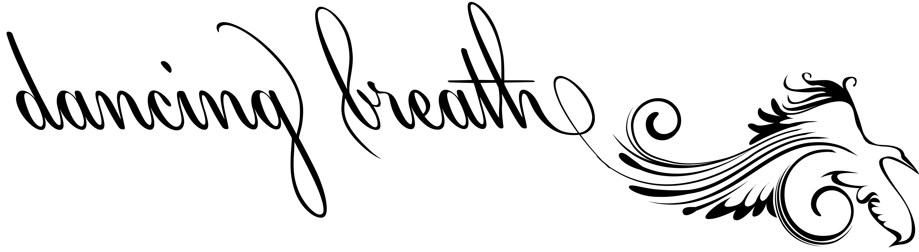
INFORMED CONSENT TO TREAT

Acupuncture, acupressure, tui na, cupping, moxibustion, gua sha, seven star, health or corrective exercises, and nutritional or herbal therapies are considered experimental procedures and are not considered a substitute for Western Medical care. Therapies and adivce offered shall not be construed by the patient to be a Western Medicine diagnosis or treatment of any disease or injury. It is recommended that you consult your physician for any condition and get at least two medical opinions. It is your right and responsibility for your own health.
The Colorado Acupuncture Practice Act states, "Practice of acupuncture" means the insertion and removal of acupuncture needles, the application of heat therapies to specific areas of the human body, and adjunctive therapies. Adjunctive therapies within the scope of acupuncture may include manual, mechanical, thermal, electrical, and electromagnetic treatment; the recommendation of therapeutic exercises; and, subject to federal law, the recommendation of herbs and dietary guidelines. The "practice of acupuncture" is based upon traditional and modern oriental medical concepts and does not include the utilization of western medical diagnostic tests and procedures, such as magnetic resonance imaging, radiographs (X rays), computerized tomography scans, and ultrasound. Nothing in this article authorizes an acupuncturist to perform the practice of medicine; surgery; spinal adjustment, manipulation or mobilization: or any other form of healing except as authorized by this article.
Acupuncture has been explained to me as a treatment consisting of the insertion of acupuncture needles through the skin at certain points on the body, as well as other Oriental modalities as described by the Colorado Acupuncture Practice Act. The purpose being to alleviate or lessen symptoms or disorders.

I understand that complications may result from acupuncture treatment. Among these possible complications are: areas of numbness, fainting, weakness, nausea, hematoma, bleeding, infection, pain and discomfort, pneumothorax, and aggravation of present symptoms.

By signing below you attest that you have read and understand everything herein.

Signature ______________________________________________________
Printed Name ____________________________________________________
Date __________________________

